Chapter 13, Solution 49.

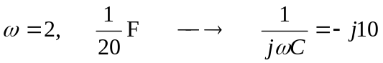

I_{x} -j10

2  I₁ 1:3 I₂

1 2
+  +
+ V₁ V₂
6
12<0º V - -
- 

At node 1,

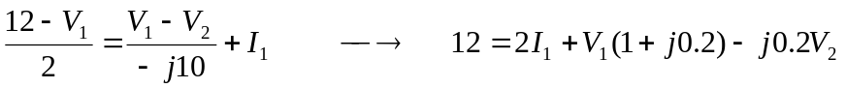 (1)
At node 2,
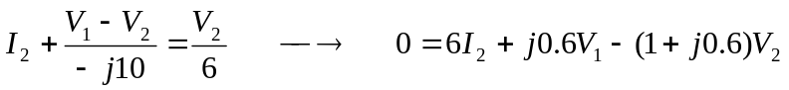 (2)
At the terminals of the transformer, 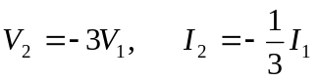
Substituting these in (1) and (2),

Adding these gives V₁=1.829 –j1.463 and

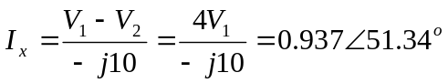

i_{x}(t) = 937cos(2t+51.34˚) mA.

